**Chapter 6 - Salts**

**All Lectures Uploaded on YouTube:**

[**https://tinyurl.com/fkm10-chemistry**](https://tinyurl.com/fkm10-chemistry)

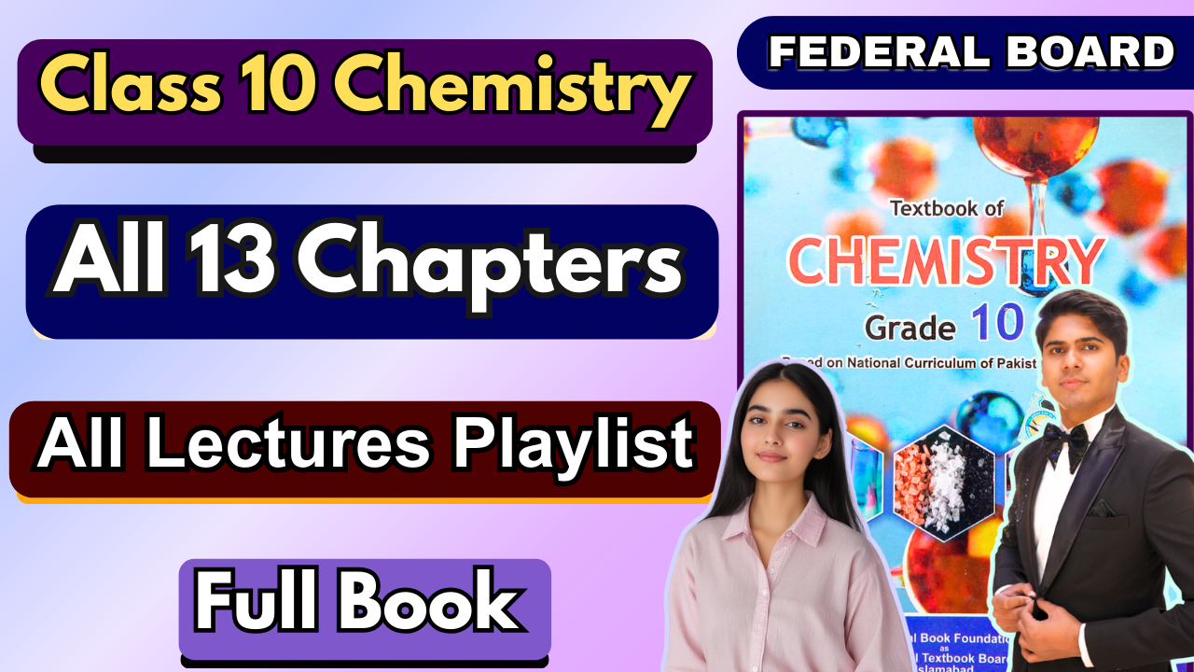

**6.1. Salts**

Salts are ionic compounds.

**Formation:** They are formed by the electrostatic attraction between oppositely charged ions known as cations (positive ions) and anions (negative ions).

**Origin of Ions:** These ions originate from acids and bases. **Bases** provide the **cations (positive ions)**. **Acids** provide the **anions (negative ions)**. The combination of these positive and negative ions results in a neutral compound—the salt.

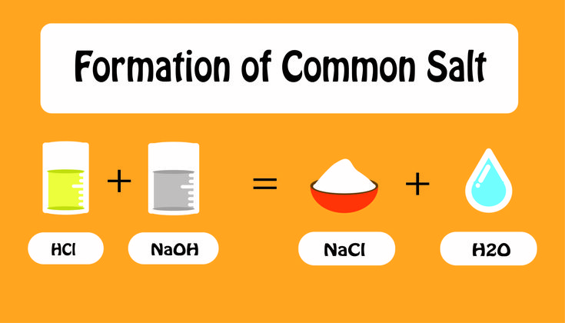

**Example Reaction:**

**Acid:** Hydrochloric Acid (HCl) → provides Cl⁻ anions.

**Base:** Sodium Hydroxide (NaOH) → provides Na⁺ cations.

**Salt Formed:** Sodium Chloride (NaCl), common table salt.

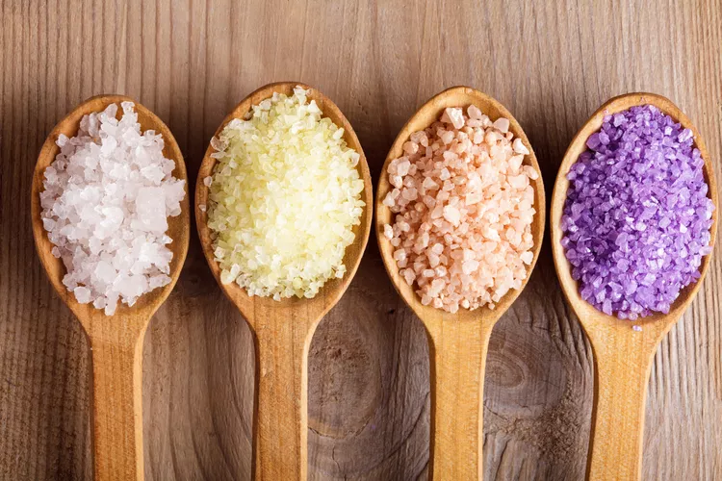

The driving force behind the formation is the **electrostatic attractive force** between the oppositely charged ions, leading to **ionic bonding**.

**6.2. Physical State and Melting Points**

**6.2.1. Solids at STP**

**Physical State:** At Standard Temperature and Pressure (STP), salts are usually **solids**.This solid state is due to the **strong electrostatic forces of attraction** between the oppositely charged ions.

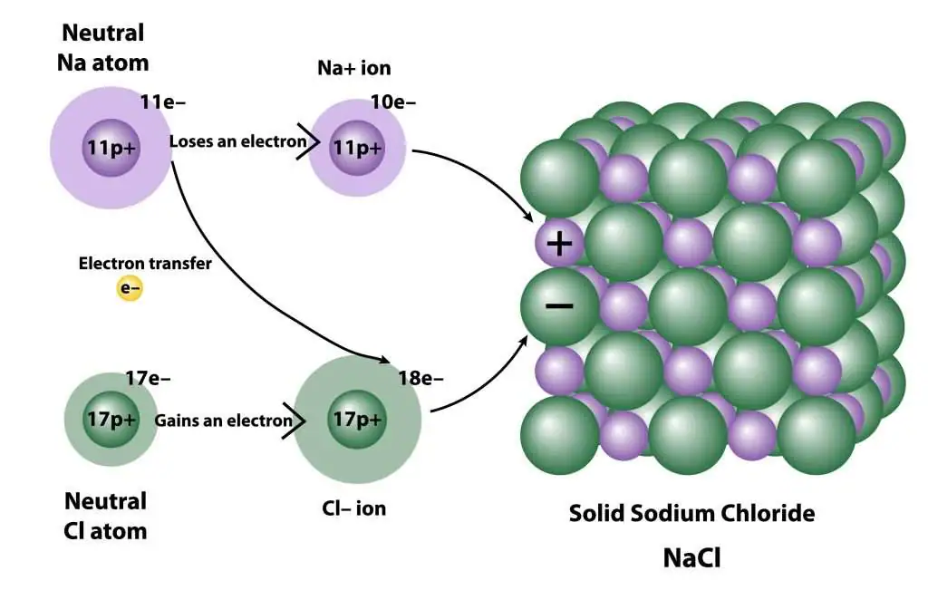

**Structure:** These forces create a **tightly bound lattice structure**.

**Melting Points:** A significant amount of energy is required to overcome these strong forces. This is why ionic compounds have **high melting points**.

**6.2.2. Lattice Structure of Ionic Compounds**

Under normal conditions, ionic compounds are solids with a well-defined structure. This is due to the nature of **ionic bonds**, which are the electrostatic attractions between cations and anions.

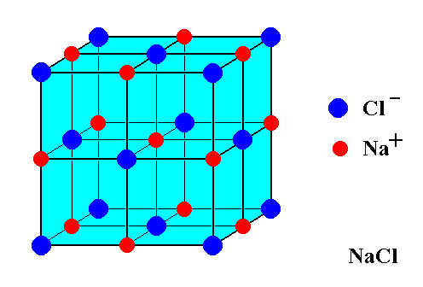

**Crystal Lattice:** The ions are arranged in a repeating, three-dimensional pattern called a **crystal lattice**.

**Purpose of the Lattice:** This specific arrangement is crucial because it **maximizes the electrostatic attractions** between oppositely charged ions while simultaneously **minimizing the repulsions** between like-charged ions. This leads to a very stable and strong structure.

**6.2.3. Electrical Conductivity**

**Conducting States:** Molten (liquid) and aqueous (dissolved in water) solutions of salts are **good conductors of electricity**.

**Reason for Conductivity:** The presence of **free-moving ions** that can carry electrical charge.

**Solid State: Does it conduct? No**. In a solid salt, the ions are locked into a **rigid lattice structure** by strong ionic bonds. They are **not free to move**, and without mobile charge carriers, electricity cannot be conducted.

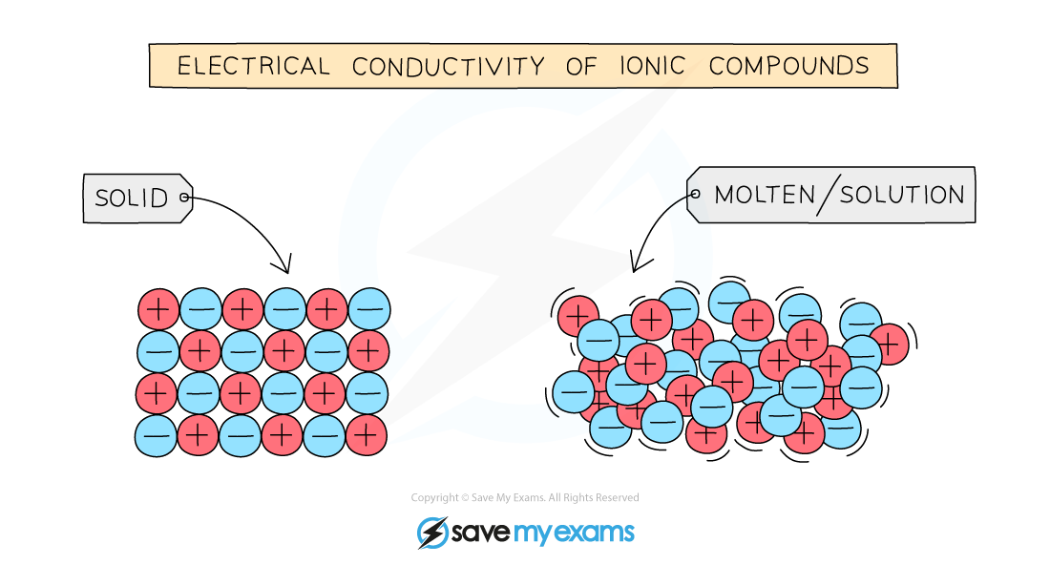

**Molten (Liquid) State: Does it conduct? Yes**. High temperature breaks down the rigid lattice. The ions are now **free to move**.The free-moving **cations (positive ions)** and **anions (negative ions)** can carry charge. When an electric potential is applied, they move, allowing conduction.

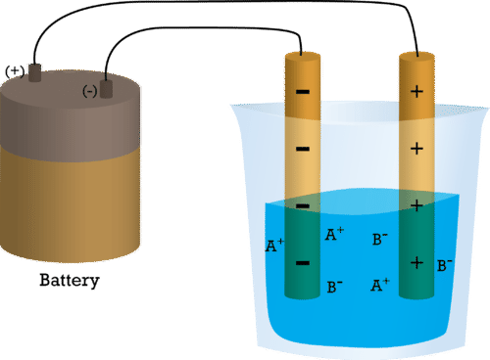

**Aqueous Solution (Dissolved in Water):Does it conduct? Yes** The polar water molecules cause the salt to **dissociate** into its constituent ions (e.g., NaCl → Na⁺ and Cl⁻). These ions are surrounded by water molecules but are **free to move** within the solution. When an electric potential is applied:

▪ **Cations (Na⁺)** migrate towards the **cathode (negative electrode)**.

▪ **Anions (Cl⁻)** migrate towards the **anode (positive electrode)**.

This movement of ions completes the electrical circuit, allowing conduction.

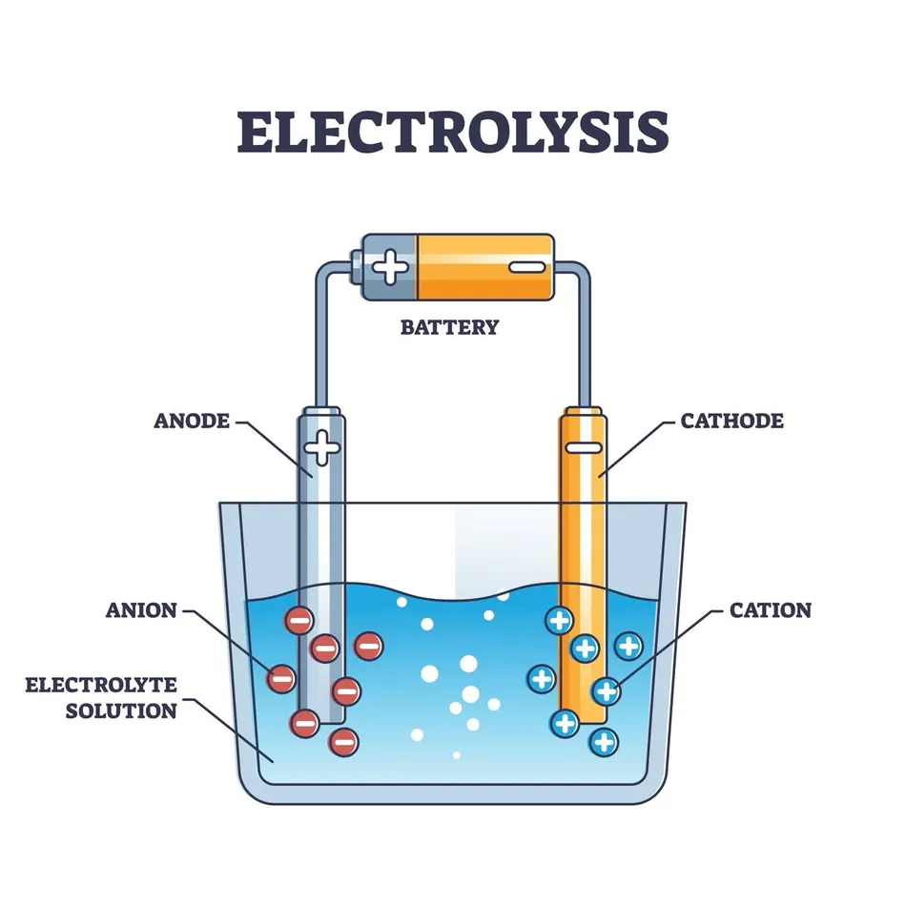

In both molten and aqueous states, the key condition is met: the **ionic lattice is disrupted**, **liberating the ions**. These free-moving ions, under the influence of an electric field, enable electrical conduction.

**6.2.4. High Melting Points and Boiling Points**

The **strong electrostatic forces** holding the ionic lattice together require a **significant amount of energy** to break. This high energy requirement translates directly into **high melting points and high boiling points** for ionic compounds.

**State at STP:** Reinforces that they are solid at STP due to these strong forces.

**6.2.5. Hardness and Brittleness**

**Hardness:** The stiffness and strength of the lattice structure make ionic compounds **hard**.

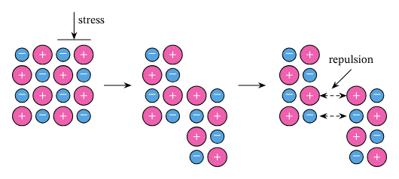

**Brittleness:** However, they are also **brittle** and tend to shatter. When a force is applied, it can shift the layers of the lattice. This movement can bring ions of the **same charge (like-charged ions) close together**. When this happens, they **repel each other** strongly. This repulsive force causes the lattice to split and break apart.

**Examples of Ionic Compounds:**

o Sodium Chloride (NaCl)

o Potassium Bromide (KBr)

o Calcium Carbonate (CaCO₃)

o Magnesium Sulphate (MgSO₄)

Each of these compounds forms a distinct **crystal lattice** that determines their structure and many of their physical properties, such as hardness and brittleness.

**6.3. Preparation, Separation, and Purification of Soluble Salts**

Soluble salts can be prepared through various methods, depending on the nature of the reactants involved. The general process often involves a reaction to form the salt, followed by separation and purification via crystallization.

**Preparation by Titration (Acid and Alkali)**

Preparation of Sodium Chloride (NaCl).

**Reaction:** HCl(aq) + NaOH(aq) → NaCl(aq) + H₂O(l)

**Principle:** This method is used when both the acid and the base are **soluble**. Titration ensures that the reactants are mixed in exactly the correct proportions to achieve complete neutralization without any excess.

**Materials Required:** Dilute HCl, Dilute NaOH, Phenolphthalein indicator, Burette, Pipette, Conical flask, Funnel, Evaporating dish, Burette stand, Tripod stand, Heating source.

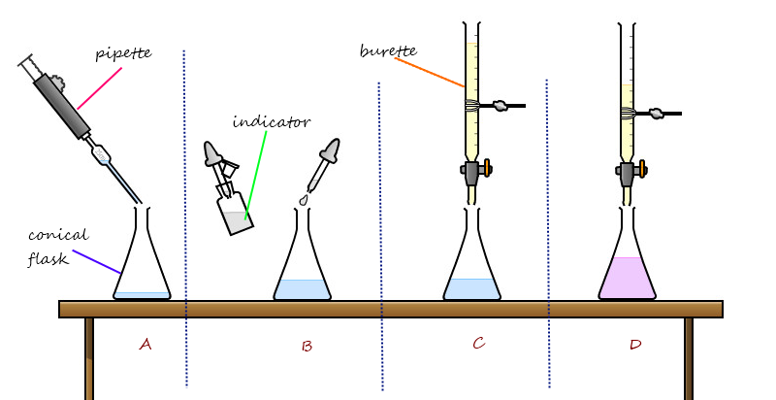

**Procedure:**

1. **Measurement:** Precisely measure 25 cm³ of HCl solution using a pipette and place it in a conical flask.

2. **Indicator:** Add a few drops of **phenolphthalein** indicator to the acid. It will be colourless.

3. **Filling Burette:** Fill a burette with the NaOH solution.

4. **Titration:** Slowly add NaOH from the burette to the HCl in the flask while swirling continuously. The endpoint is reached when a **light pink colour** persists, indicating the solution is neutral.

**Separation & Purification:**

1. **Crystallization:** The resulting solution contains dissolved NaCl.

▪ Gently **evaporate** some of the water to form a hot, saturated solution. ▪ **Allow the solution to cool.** As it cools, the solubility of NaCl decreases, and crystals form.

2. **Collection:** Filter the mixture to collect the pure NaCl crystals.

**Preparation with Excess Metal**

Preparation of Zinc Sulphate (ZnSO₄).

**Reaction:** Zn(s) + H₂SO₄(aq) → ZnSO₄(aq) + H₂(g)

**Principle:** This method is used to prepare a salt from a reaction between an acid and a metal. The **metal is used in excess** to ensure **all of the acid is completely reacted**.

**Observation:** Bubbles of **hydrogen gas** are produced.

**Materials Required:** Zinc metal, Dilute sulphuric acid, Beaker, Glass rod, Filter funnel and paper, Evaporating dish, Tripod stand, Wire gauze, Heating source.

**Procedure:**

1. **Measurement:** Measure 25 cm³ of dilute sulphuric acid into a beaker.

2. **Reaction:** Add **excess zinc metal** to the acid. Bubbles of hydrogen gas will appear.

3. **Confirm Completion:** Continue adding zinc until some solid remains unreacted, confirming that no more acid is left to react.

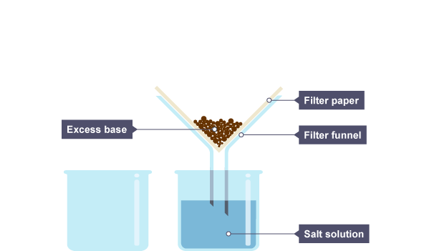

**Separation & Purification:**

1. **Filtration:** Filter the mixture to **remove the unreacted excess zinc metal**. 2. **Crystallization:**

▪ Evaporate the **filtrate** (the solution that passes through the filter, containing ZnSO₄) to obtain a hot, saturated solution.

▪ Allow it to cool and crystallize.

3. **Collection:** Filter the mixture to collect the pure ZnSO₄ crystals.

**Preparation with Excess Insoluble Base**

Preparation of Copper(II) Sulphate (CuSO₄).

**Reaction:** CuO(s) + H₂SO₄(aq) → CuSO₄(aq) + H₂O(l)

**Principle:** This method is used when the base is **insoluble** in water. The **insoluble base (Copper(II) oxide) is used in excess** to ensure all the acid is used up.

**Materials Required:** Copper(II) oxide, Dilute sulphuric acid, Beaker, Glass rod, Filter funnel and paper, Evaporating dish, Tripod stand, Wire gauze, Heating source.

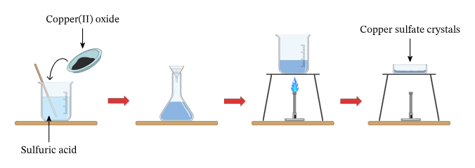

**Procedure:**

1. **Measurement:** Measure 25 cm³ of dilute sulphuric acid into a beaker. 2. **Reaction:** Add **excess copper(II) oxide** to the acid.

3. **Confirm Completion:** Heat the mixture and continue adding CuO until no more solid dissolves. The presence of undissolved solid indicates that all the acid has reacted.

4. **Filtration:** Filter the mixture to **remove the unreacted excess copper(II) oxide (CuO)**.

5. **Crystallization:**

▪ Evaporate the **filtrate** (the solution that passes through the filter, containing CuSO₄) to obtain a hot, saturated solution.

▪ Allow the solution to cool and crystallize.

6. **Collection:** Filter the mixture to collect the pure CuSO₄ crystals.

**Preparation with Excess Insoluble Carbonate**

Preparation of Calcium Chloride (CaCl₂).

**Reaction:** CaCO₃(s) + 2HCl(aq) → CaCl₂(aq) + CO₂(g) + H₂O(l)

**Principle:** This method is used to prepare a salt from a reaction between an acid and a carbonate. The **insoluble carbonate is used in excess** to ensure **all of the acid is completely reacted**.

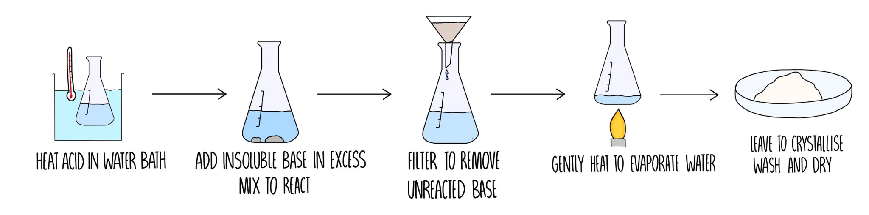

**Observation: Effervescence (bubbles)** are observed as **carbon dioxide gas** is evolved.

**Materials Required:** Calcium carbonate (limestone), Dilute hydrochloric acid, Beaker, Glass rod, Filter funnel and paper, Evaporating dish, Tripod stand, Wire gauze, Heating source.

**Procedure:**

1. **Measurement:** Measure 25 cm³ of dilute hydrochloric acid into a beaker. 2. **Reaction:** Add **excess calcium carbonate (CaCO₃)** to the acid. Effervescence will be observed due to CO₂ production.

3. **Confirm Completion:** Continue adding CaCO₃ until **no more effervescence is observed**. This indicates that all the acid has been used up.

**Separation & Purification:**

1. **Filtration:** Filter the mixture to **remove the unreacted excess calcium carbonate (CaCO₃)**.

2. **Crystallization:**

▪ Evaporate the **filtrate** (the solution that passes through the filter, containing CaCl₂) to obtain a hot, saturated solution.

▪ Allow it to cool and crystallize.

3. **Collection:** Filter the mixture to collect the pure CaCl₂ crystals.

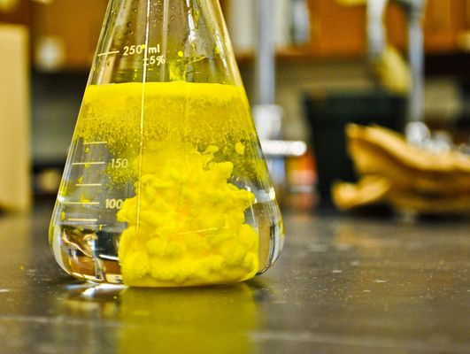

**6.4. Soluble and Insoluble Salts**

**Soluble Salts:** Salts that **dissolve** in water at room temperature. **Insoluble Salts:** Salts that **do not dissolve** in water at room temperature.

**General Solubility Rules:** These rules help predict whether a given ionic compound will dissolve in water. They are essential for understanding reactions in aqueous solutions.

**All Sodium (Na⁺), Potassium (K⁺), and Ammonium (NH₄⁺) salts are soluble.**

**Examples:**

▪ Sodium Chloride (NaCl)

▪ Sodium Sulphate (Na₂SO₄)

▪ Potassium Chloride (KCl)

▪ Potassium Bromide (KBr)

▪ Ammonium Chloride (NH₄Cl)

▪ Ammonium Sulphate ((NH₄)₂SO₄)

**All Nitrate (NO₃⁻) salts are soluble.**

**Examples:**

▪ Potassium Nitrate (KNO₃)

▪ Calcium Nitrate (Ca(NO₃)₂)

**Most Chloride (Cl⁻) salts are soluble.**

**Exceptions: Lead(II) Chloride (PbCl₂)** and **Silver Chloride (AgCl)** are **insoluble**.

**Most Carbonate (CO₃²⁻) salts are insoluble.**

**Exceptions: Sodium, Potassium, and Ammonium carbonates** are **soluble**.

**Examples of Insoluble Carbonates:**

▪ Calcium Carbonate (CaCO₃)

▪ Magnesium Carbonate (MgCO₃)

**Most Sulphate (SO₄²⁻) salts are soluble.**

**Exceptions: Lead(II) Sulphate (PbSO₄)**, **Barium Sulphate (BaSO₄)**, and **Calcium Sulphate (CaSO₄)** are **insoluble**.

To summarize:

